1
3 3
91 8 71 14 2 11 6 51 3
1 2 1 3
1
3 3
9 18 7 14 2 11 6 51 3
1 2 1 3

79 25

int C[m][n]; C[i][j]

Code:
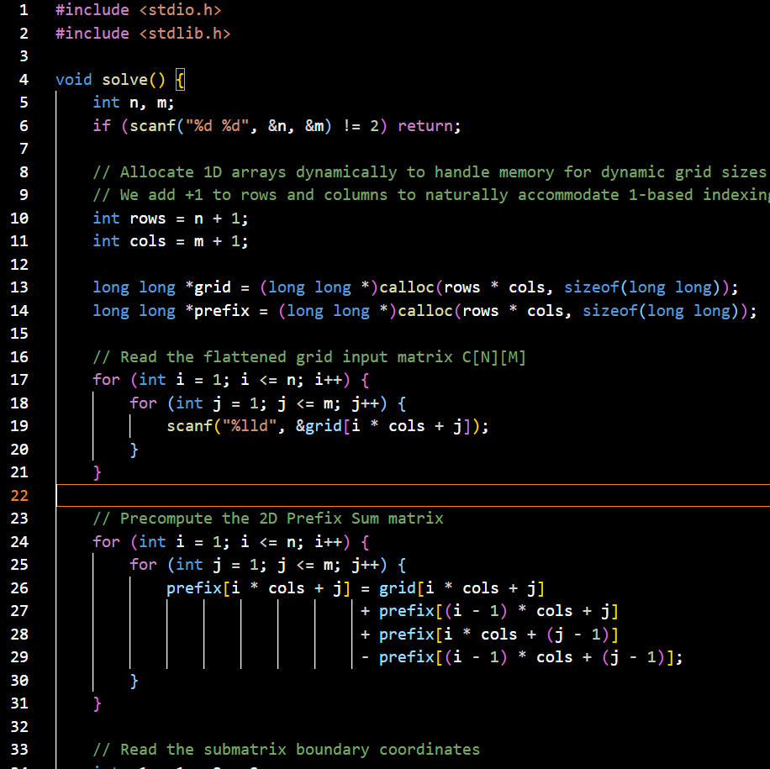

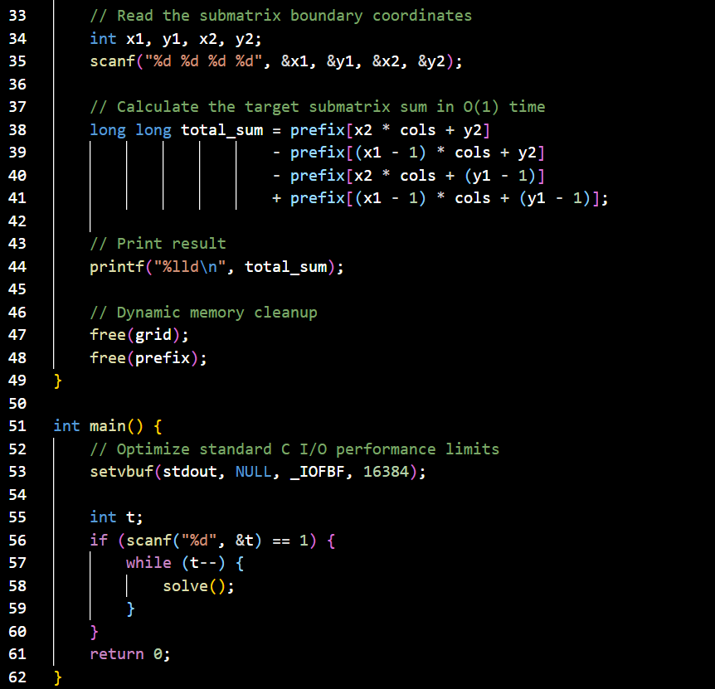

Output
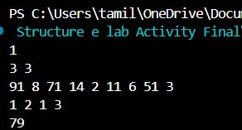

6

